Curriculum Vitae

Mark A. Mentzer, Ph.D.
72 Diana Drive, Blairsville, GA 30512
443-350-3705
markmentzer@hotmail.com
educator|author|neuroscientist (markamentzer.com)

Academic and professional history demonstrates the ability to motivate and enrich students using a unique combination of education and experience with a strong background in science and mathematics, industry, and academia. Effective dynamic teaching based on real-world expertise as an inventor, published author, corporate executive, and Army STEM Ambassador.

Professional Profile
• Adjunct Full Professor, University of Maryland Global Campus
- Taught several years in Maryland and Virginia public schools, and two years at a private college prep school
- Served as adjunct assistant Professor at Penn State University for seven years
- Taught for Technology Training Corporation for six years
- Wrote curricula for MBA programs and healthcare MBAs
- Dedicated to enthusiastic and dynamic teaching as a means of creating and nurturing a lifelong love of learning
- Familiar with Blackboard, Sakaii, and Banner online learning systems
- Multidisciplinary tutor for all ages through WyzAnt
- Implemented Berlitz courses in a global business environment
• 87 classified and open literature publications
• 4 books sole author; 2 co-authored books
• 27 patent disclosures; 14 issued patents

Education, Honors, and Certifications
MA 2018 Mathematics Education Western Governors University
MAT 2016 Teaching, Mathematics University of MD University College
MS 2012 Biotechnology Johns Hopkins University
Ph.D. 1986 Electrical Engineering University of Delaware
MAS 1983 Business Administration Johns Hopkins University
MSEE 1981 Electrical Engineering University of Delaware
BA 1979 Physics, Music Franklin & Marshall College

• Level-III Defense Acquisition University (DAU) Certification: Science
and Technology Manager, 2009
• Level-III Defense Acquisition University (DAU) Certification: Test and
Evaluation, 2010
• Member Army Acquisition Corps, 2009 to present
• 26 DAU courses in government logistics, including Harvard Business
School negotiation skills and technical leadership courses, 2008 to 2011
• Certified Test Director, 2010
• Certified Contracting Officer Representative, 2010
• Westinghouse School of Applied Engineering Science; Radar Engineering,
1982 to 1984

Certification/Licensure
Maryland Educator Certificate
Effective 1/1/17 to 12/31/21
Mathematics 7-12 Physics 7-12

Commonwealth of Virginia Provisional License
Effective 7/1/17 to 6/30/20
Mathematics Physics

Key Qualifications
• Adjunct Associate Professor, University of Maryland Global Campus
• Seven years Adjunct Assistant Professor at Penn State University
• Two years as Director and Professor in the MBA program at Lebanon
Valley College of Pennsylvania
• Eight years as an evening tutor and consultant through WyzAnt tutoring
• Full-time high school mathematics and physics teacher

Public teaching profile:
http://www.wyzant.com/Tutors/MD/PrincessAnne/8057128/

For four years, I volunteered with eCYBERMISSION, a STEM learning competition for 6th-9th graders sponsored by the U.S. Army Educational Outreach Program and administered by the National Science Teachers Association. The program’s mission is to promote STEM learning at an early age to inspire 21st-century STEM careers.

Awards
• US Army Community Service Awards- SBIR and robotics contest judge
• Army On-the-Spot Award for high-speed photography
• Armstrong Laboratory Award for Scientific Excellence
• Chief Liaison Scientist, U.S. Army ARRADCOM Research Consortium
• SPIE Service Citation
• Two Westinghouse Engineer of the Year Awards
• Best Paper Award, Government Microcircuit Applications Conference
• I.R. 100 Award
• Ferranti Commendation for Managerial Excellence
• Framatone Tiger Team Award

Contributions and Achievements
During my 36-year career, I have developed various sensors and instrumentation. I operated an aerospace defense company, managed an optical-assembly manufacturing company, and led global-product development in Europe, Asia, and the Americas. I taught graduate engineering and physics for seven years at Penn State and have presented frequently at trade shows and conferences. And I have two widely distributed books, with over six thousand copies sold in print and electronic media.
I improved instrumentation and data-collection methodologies and applied my skills to various Army missions. I have focused on five areas: biosensors, THz frequency spectroscopy, X-ray cineradiography, fiber-sensor velocimetry, and high-brightness imaging. I have proposed and executed several dozen winning program plans and proposals by applying my expertise in optical engineering, solid-state physics, biochemistry, and molecular biology. And I have frequently consulted with other branches and directorates regarding imaging and sensors. Examples of my contributions include:

• I convinced NSRDEC to use my test methodology for their Maxillofacial Protection Program. They also adopted my metrics for selecting mandibles. And to feed the down selection, Natick funded our testing to collect the necessary data. ($350K funds received). (ARL-TR-6224)
• I extended SLAD analysis and test capabilities by securing and executing more than $2M in funded programs. I accomplished this through two director’s research initiatives, a DSI, two SLAD methodology research initiatives (MRIs), and nine additional projects funded by SLAD. To determine how best to address brain injury, I expanded collaborations between SLAD, WMRD, USAMRMC, and WRAIR by presenting my mTBI theories and sharing ideas for modeling and testing material systems using my sensors. I effected technical discourse across several directorates, resulting in our collaborative DSI award with WMRD and HRED.
• By designing X-ray systems with improved temporal control of flash, I greatly improved the resolution in measuring deformations of helmet material and clay backing. This made it possible to use deformation as an evaluation method for characterizing ballistic events in terms of energy transfer and synchronizing sensor outputs to understand energy propagation better. My system is now in use at SLAD. (ARL-TR-6341)
• For high-speed videography and laser-illumination systems, I designed lithium-polymer power systems and bomb-proof housings with optimized shock damping. My designs have made it possible to see through debris and fireballs and, by eliminating tethers, made high-rate imaging aboard vehicles moving at highway speeds possible. My systems are used inside vehicles undergoing live-fire explosives tests and for testing aircraft panels.
• I developed algorithms for scoring active protection systems (APSs) that ATEC has incorporated into their evaluation method.
• I developed five SBIR topics that were funded for $2.6M. Because I had mastered the process effectively, ARL’s SBIR office enlisted me to advise others on structuring SBIR programs.
• I was appointed by the Navy to the OSD S&T working group on multispectral tests as chair of the subcommittee on RF and microwave testing. I later switched to chairing the subcommittee on behind-armor blunt trauma (BABT).
• As a consultant for the National Research Council (NRC), I resolved industry concerns about testing and instrumentation for BABT. I conducted industry sensing sessions and reported issues to the NRC, which incorporated my recommendations into their report to Congress.

Employment

Career Overview

My accomplishments as a successful technical leader and multidisciplinary contributor led several employers to offer a progression of opportunities with ever-increasing authority, responsibility, and remuneration. With this background, I now routinely contribute effective processes, programs, and products. And for this phase of my career, I am honored to serve our students, applying my skills in service to the mission of education.

• 2016-Present, University of Maryland Global Campus, Adelphi, MD; Part-time Full Professor; Teach graduate systems engineering and information technology courses: Information Systems Analysis, Modeling, and Design; Design Considerations; Model-Based Systems Engineering; Assist in new course development
• 2017-2021, Eastern Shore Community College, Melfa, Virginia; Associate Professor of Mathematics; taught Pre-Calculus, Business Math, and Statistics
• 2018-2019, The Salisbury School, Salisbury, Maryland; high school math teacher; taught Geometry, Pre-Calculus, Finite Math, and Algebra 2
• 2017 to 2018, Nandua High School, Onley Virginia; high school math teacher; taught Algebra 1/2, Geometry, Algebra, Functions, Data and Analysis, Trigonometry

• 2015-2017, Broadwater Academy, Exmore VA; full-time math and science teacher; taught AP Calculus AB and BC, Honors Biochemistry and Molecular Genetics, Honors Advanced Physics, Pre-Calculus, Marine Technology, Engineering and Robotics, and Mathematics for Engineering and the Life Sciences; coached math and robotics teams; math team and individual student took second place at Eastern Shore Math Competitions; robotics team placed 18th at National Robotics Competition; served as Director, Center for Integrated Math and Science, coordinating math and science curricula for grades 6-12

• 2014-2015, Crisfield High School; MD; full-time high school mathematics teacher; taught College Math, Algebra II, Pre-Calculus, AP Calculus AB; taught evening GED class 3 nts/wk; coached Math Team; conducted Math Club 5 nts/wk.

• 2012-Present, WyzAnt Tutoring, Teaching, and Coaching; Chicago;

Private Academic Tutor; Assist 6th graders through graduate students in a variety of subject areas; Tutor for test preparation, including HSA, MSA, PSAT, SAT, ACT, GRE, GMAT, LSAT, and MCAT

• 2014, Somerset County School District; MD; Substitute Teacher; Taught in nearly every school in the district, in various academic disciplines; served as long-term mathematics substitute for Washington High School and Academy, Princess Anne, MD. Taught Geometry, Applied Geometry, Algebra I and II, Pre-calculus, HSA Prep, and bridging math

• 2013-2015, Bishop & Associates Inc. (Industry Analysts); Chicago; Director, Renewable Energy, Medical, and Military; Analyzed industry trends and data, formulated industry analysis reports, published articles for several trade publications (worked from home)

• 2011–2014, ARL, APG, MD; research scientist designing sensors and instrumentation, leading director’s strategic initiative (DSI) research in neurosciences and mild traumatic brain injury (mTBI)

• 2008‒2011, ATC, APG, MD; optical engineer, engineering team leader for 11 technical personnel, Plans and Operations, Technical Imaging Division

• 2007‒2008, Advanced Systems International (ASI) Technologies, Inc.; Lancaster, PA; co-founder/director of engineering

• 2001‒2007, William P. Strube, Inc.; Marietta, PA; president and general manager

• 2000‒2001, Lucent Bell Laboratories/InLight Communications; Allentown, PA and Fremont, CA; Optical microelectromechanical systems (MOEMS) technology, director, business development/vice president

• 1996‒2000, FCI Framatome Electronics Group Inc.; Valley Green, PA, and Paris, FR; global business director, fiber optic products

• 1990‒1996, BURLE Industries, Inc. (RCA New Products Division); Lancaster, PA; director, application engineering, image, and display tube products

• 1987‒1996; taught eight different courses at Penn State (adjunct assistant professor) for seven years; directed MBA program at Lebanon Valley College for two years

• 1984‒1990, Ferranti International Corp.; Lancaster, PA & Edinburgh, UK; director, advanced development group

• 1981‒1984, Westinghouse Defense and Electronics Systems Center (DESC); Baltimore, MD; senior supervisory engineer (six months out of graduate school)

Achievements and Impact
Biosensor Inventions for Mild Traumatic Brain Injury (mTBI), 2008 to present
I developed an mTBI sensor to accurately correlate biomechanical data to biomedical and identify neuronal injury thresholds. I abstracted the relationship of neuronal injuries to their insult thresholds from the literature and calibrated my sensor outputs to these injury modalities. This has made it possible to identify Soldiers in the field who will require treatment and to predict from specific injuries received what would be the most appropriate therapies. Having seen my sensor, MRMC encouraged me to design a field-portable diagnostic for biomarkers, which I did as a lab-on-a-chip microfluidic assay that detects protein biomarkers. My assay chip allows further diagnosis for Soldiers with injuries detected by my sensor system.
I successfully presented my mTBI sensor concepts and received DSI and SLAD development funding. Next, I submitted invention disclosures for my sensor designs and received the highest rating (“PO”) from ARL’s invention evaluation committee. ARL then filed regular and provisional patent applications, both domestically and abroad (Docket No. ARL 11-33). As a result, ARL is now positioned to license my emergent biosensor technologies to the industry.
My sensors have been demonstrated to function as intended and are in calibration testing at Encapsula Nanosciences. I proved the concept for my sensor for such neurological damages as diffuse axonal injury and axon-glia dysfunction. I validated my sensor by designing a sensor-test chamber that used a fluid-percussive injury apparatus and showed that my sensor replicates injury-based biomarker medical data from the literature. I then correlated this data to my sensor output, thus accurately assessing injuries.
IMPACT: My sensor illuminates the relationship between injury thresholds and WMRD’s blast testing of neuronal tissue cultures. This also makes it possible to relate injury thresholds to HRED’s electrophysiological measurements of human function. With WMRD, I related computational cellular and molecular models to injury prediction based on my sensor metrics. This is the basis for more accurate injury prediction and for relating my sensor data to models for tissue damage.

Improvements to Aircraft Safety, 2000–2007
Because of TWA 800 and the explosions of two military aircraft, the National Transportation Safety Board (NTSB) asked me to evaluate two potential causes of those tragedies: chafing of wiring harnesses that might cause sparking and nitride deposits on fuel probes that might cause arcing. For the wiring harnesses, I came up with redesigns; and for the probes, I revised maintenance schedules. Then I also invented probes that use optical waveguides and thus eliminate the potential for explosion. [U.S. patents 7,573,565; 7,710,567; 7,671,539; 6,831,290; and World Patent WO 2004/008086].
IMPACT: My improved wiring harnesses and maintenance schedules are in use on all large aircraft for commercial aviation except the 777 and for some models of C130s and KC135s. As to my probe, it is currently being qualified by the system integrator for Boeing and Airbus to be used for several commercial and military aircraft.

International Business Development and Leadership, 1996–2000
As global business director for the French conglomerate Framatome (aka FCI), I managed 284 employees. I founded my management approach upon cultural awareness and sensitivity, social customs, regional business practices, and communication strategies. I directed engineering-development centers in Tokyo, Iwaki City, Brussels, Paris, Grenoble, Kansas City, Valley Green, and Juarez, and I standardized on optimized practices. I also developed new optical connectors and manufacturing processes and received several patents during this time. My leadership approach earned me awards from my senior management, who took my advice to have Berlitz incorporate my system into two internal courses for the company: How to Do Business in Mexico and How to Do Business in Japan.
My new assembly processes and lower-cost facilities (including the new plant in Mexico, which I established) allowed FCI to capture one-third of the global market. I obtained customer qualification for 43 product lines in my Mexican facility in one-fiftieth of the time typically required, giving us a year’s head start over our competition. In this way, my contributions raised our annual sales from $2.2M to $42M in four years, and we became Lucent’s largest supplier at more than $40M in yearly sales.
IMPACT: I produced colossal growth, profitability, and hundreds of new jobs. This stimulated the French government to buy out the company, where my product line remains an industry leader (second only to Tyco in gross revenues) in component sales to the global networking industry.

Optical Micro-Electromechanical Systems (MOEMS), 1986-2001
Developments in the telecommunication markets of the mid-80s created an excellent demand for higher-performance MOEMS networks and switches. At Westinghouse, I developed the first practical MOEMS packages. Then, while a business-unit manager for Lucent, I was contacted by a former Israeli finance minister who provided the venture capital with which I started a company, where I further developed MOEMS. We eventually sold the company for $15.5M. At my start-up, I developed processes for releasing and actuating mirrors. Because this led to significantly improved yields and practicability for the MOEMS industry, the commercialization of reconfigurable switches was possible.
I designed MOEMS to couple detectors to waveguides and lasers, and IBM adopted my MOEMS package in their LiteBus system to connect computers to laser arrays. XROS Corp. adopted a mirror actuation system of my design-led Northern Telecom to buy them out for $8.6B.
In another MOEMS application, I produced a subsystem for wavelength division multiplexing, which I coupled to my MOEMS optical switch. This raised switching rates by more than a factor of one hundred. My significant innovations here were packing efficiency, backplane connectivity, and the transceiver that allowed the system to operate at a very high bandwidth. My customer, Sycamore Networks, adopted my entire MOEMS package, demonstrating superior switching and routing capability. By performing an industry demonstration of the integrated MOEMS system, Sycamore achieved an IPO of $14.4B, the largest in history for an internet-related company. [See “Sycamore shares soar in stunning debut” http://news.cnet.com/2100-1033-231775.html last accessed 30 April 2013.]
IMPACT: My MOEMS subsystems, under license to Lucent, Nortel, and Corvis, strengthened their competitiveness in huge global markets with bandwidths enabling emerging subscriber area networks. My multi-fiber array connectors overcome such challenges as stability during temperature cycling and alignment tolerance, thereby meeting the demanding standards applicable to telecommunication and avionics markets. My optical transceiver packages are used in IBM’s LiteBus line of parallel optical devices. [U.S patents 6,422,761; 6,447,171]

Computer Memory Chip Inventions, 1981–1986
The mission of the Trident missile required that it be hardened against nuclear effects, to which most electronics of the early 1980s were highly vulnerable. To meet this need more reliably and at lower space, weight, and power, I developed a nonvolatile memory that allowed missiles to recover critical state quickly. By inventing thin-film memory employing stable magnetization domain states, I achieved random-access addressing of memory cells and fabrication using standard semiconductor processes. My inventions improved reliability, power consumption, speed, and cost, over the alternative plated-wire and core memories.
Within six months of starting my first job out of school, I became supervisor of 12. I was selected twice consecutively by over 2,000 engineers and physicists as Westinghouse DESC’s engineer of the year. I took my project from proof of concept to high-volume production in two years, roughly one-third the time typically required. I was awarded several patents for my innovations in memory technology.
IMPACT: My crosstie random-access memory (CRAM) intellectual property significantly contributes to the Trident missile program. This IP suite [U.S. patents 4,722,073 and 4,841,480, plus additional disclosures and process technology] was purchased from Westinghouse by IBM Corp., which uses my thin-film concepts in their idle-mode flash memory, which is coming to the market shortly. This memory will reduce start-up time for personal electronic devices.

Pioneering Work in Integrated Optics, 1980–2010
In the early 1980s, engineers incorporating optical subsystems into electronics encountered problems with integrability, compatibility, and manufacturability. I developed monolithically integrated optical componentry techniques by altering materials via ion implantation, molecular-beam epitaxy, and metal-organic chemical vapor deposition. ARRADCOM adopted my algorithms and optical devices for programmable logic functions to extend the versatility of fire control systems. This afforded signal processing in operating environments too harsh for existing electronics. I developed optical design software and conducted tutorial lecture tours. Ft. Monmouth and Ft. Belvoir Night Vision and Electro-Optic Laboratory used my software to design directional couplers and electro- and acousto-optic modulators.
IMPACT: My work contributed to the early success of integrated optics. By improving manufacturing processes, I was able not only to achieve working devices but to obtain several per chip. My integrated optical signal processing improved bandwidth capacity by over 100 and allowed multiple optical-logic functions on a common substrate. This benefited the system designer by increasing yields and lowering development costs. A representative example was the Air Force’s use of my acousto-optic correlators for analog-signal analysis in the AN/AVQ-23 PAVE SPIKE laser designator. My modulators and geodesic lens designs were used in Harry Diamond Laboratory convolvers for radar-signal processing, where they outperformed electronic systems in both resolution and bandwidth.

Computer Skills
• Microsoft Windows® Office Suite, UNIX
• Proficient in molecular biology software, including “ohmic” data structures, Perl,
SQL, JAVA platforms.
• Familiar with a variety of education delivery systems

Professional Affiliations
• National Neurotrauma Society
• American Association for the Advancement of Science
• Institute of Electrical and Electronics Engineers
• International Society for Photo-Optical Instrumentation Engineering
• Optical Society of America
• National Council for Teachers of Mathematics

Publications and Books

1. J.M. Zavada, H.A. Jenkinson, T.J. Gavanis, R.G. Hunsperger, M.A. Mentzer,

D.C. Larson, and J. Comas, “Substrate Temperature Effects In Proton Implanted

GaAs Infrared (10.6 Micron) Waveguides,” Proc. SPIE 239, 24th International
Technical Symposium, San Diego, CA, 157, July 1980.
2. M.A. Mentzer, R.G. Hunsperger, H.A. Jenkinson, J.M. Zavada, and T.J. Gavanis,
“Visible and Infrared Waveguiding in GaP,” Proc. IEEE/OSA Third Int. Conf. on
Integrated Optics and Optical Fiber Communications (IOCC ’81), San Francisco,
CA, April 27-29, 1981.
3. M.A. Mentzer, R.G. Hunsberger, J.M. Zavada, H.A. Jenkinson, and T.J. Gavanis,
“Visible and Infrared Waveguiding In Proton Implanted n-type GaP,” Proc. SPIE
317, Conf. on Integrated Optics and Millimeter and Microwave Integrated
Circuits, Huntsville, AL, 108, November 16-19, 1981.
4. D. Mergerian, E.C. Malarkey, R.P. Pautienus, JK.C. Bradley, M. Mill, C.W.
Baugh, A.L. Kellner, and M.A. Mentzer, “Advanced Integrated Optic rf Spectrum
Analyzer,” Proc. SPIE 321, Conf. on Integrated Optics II, Los Angeles, CA, 149,
January 28-29, 1982.
5. C.W. Baugh, J. Cullom, E.A. Hubbard, M.A. Mentzer, and R. Fedorak,
“Fabrication and Characterization of a Crosstie Random Access Memory,” IEEE
Trans. Magnetics, 3IM3 Conference, Montreal, Quebec, July 1982.
6. M.A. Mentzer, C.W. Baugh, E.A. Hubbard, R. Fedorak, and L.J. Schwee,
“Magnetic Crosstie Random Access Memory,” Proc. Government Microcircuit
Applications Conference (GOMAC ’82), Orlando, FL, November 2-4, 1982.
7. M.A. Mentzer, R.G. Hunsberger, J.M. Zavada, H.A. Jenkinson, and T.J. Gavanis,
“Characterization and In-Process Optimization of Infrared Ion Implanted GaP
Optics,” Proc. OSA Workshop on Optical Fabrication and Testing (OF&T) ’82),
Palo Alto, CA, December 13-15, 1982.
8. J.M. Zavada, H.A. Jenkinson, T.J. Gavanis, R.G. Hunsperger, and M.A. Mentzer,
“Characteristics of Optical Waveguides Formed by Ion Implantation,” U.S. Army
Armament Research and Development Command, Fire Control, and Small Caliber
Weapon Systems Laboratory, Dover, NJ, Technical Report ARSCD-TR-82023,
January 1983.
9. M.A. Mentzer, M.S. Wlodowski, R.G. Hunsperger, J.M. Zavada, H.A. Jenkinson,
and T.J. Gavanis, “ Characterization and Optimization of Proton Implanted
Optical (1.15 um) GaAs Waveguides,” Proc. SPIE 408, Conf. on Integrated
Optics III, Arlington, VA, 38, April 5-6, 1983.
10. M.A. Mentzer, R.G. Hunsperger, J.M. Zavada, H.A. Jenkinson, and T. J.
Gavanis, “Temperature Processing Effects in Proton Implanted n-type GaAs,”
Appl. Phys. A32, 19-25 (1983).
11. M.A. Mentzer, R.G. Hunsperger, S. Sriram, J. Bartko, J.M. Zavada, and H.A.
Jenkinson, “Guided Wave Device Design and Fabrication for Monolithic
Integration in GaAs,” Proc. SPIE 460, Conf. on Processing of Guided Wave
Optoelectronic Materials, Los Angeles, CA, 65, January 24-25, 1984.
12. M.A. Mentzer and G.E. Marx, “Lithium Niobate and Gallium Arsenide Integrated
Optical Devices for Optical Switching,” U.S. Army Research Office Sponsored
Workshop on Optical Switching Technology, Los Angeles, CA, March 1984.
13. M.A. Mentzer, R.G. Hunsberger, J. Bartko, J.M. Zavada, and H.A. Jenkinson,
“Infrared Ion Implanted GaAs Optics,” Proc. OSA Workshop on Optical
Fabrication and Testing (OF&T ’84) Monterey, CA, April 18-20, 1984.
14. M.A. Mentzer, J. Bartko, R. G. Hunsperger, J.M. Zavada, and H.A. Jenkinson,
“Ion Implantation Fabrication of GaAs Integrated Optical Components,” Proc. 5th
International Conference on Ion Implantation Equipment and Techniques,
Jeffersonville, VT, July 23-27, 1984.
15. M.A. Mentzer, R.G. Hunsperger, J. Bartko, J.M. Zavada, and H.A. Jenkinson,
“Ion Implanted GaAs Integrated Optics Fabrication Technology,” Proc. SPIE 517,
First International Conference on Integrated Optical Circuit Engineering,
Cambridge, MA October 23-25, 1984.
16. C.W. Baugh, E.A. Hubbard, J.F. Jackson, D. Lampe, and M.A. Mentzer, “Signal
Processing and Architecture for the Crosstie Random Access Memory,” Proc.
Government Microcircuit Applications Conference (GOMAC ’84), Las Vegas,
NV, November 6-8, 1984.
17. M.A. Mentzer, R.G. Hunsperger, S. Sriram, J. Bartko, M.S. Wlodowski, J.M.
Zavada, and H.A. Jenkinson, “Ion Implanted Optical Waveguides in Gallium
Arsenide,” Optical Engineering, 24(2), 225-229, March/April 1985.
18. L.D. Hutcheson and M.A. Mentzer, “Design Criteria for AlGaAs/GaAs Integrated
Optoelectronic Devices,” Proc. SPIE 704, Integrated Optical Circuit Engineering
IV, Cambridge, MA, September 16-17, 1986.
19. G.C. Vezzoli, W. Cadwallender, M.A. Mentzer, L.R. Megargel, D.E. Craley,
“Optical Oscillation Established Using Acousto-Optic Bragg Angle Diffraction in
Conjunction With Closed Cavity Feedback,” Proc. SPIE 704, Integrated optical
Circuit Engineering IV, Cambridge, MA, September 16-17, 1986.
20. J. Sun, C.S. Ih, M.A. Mentzer, A. Grot, and B. Wang, “Fiber Optic Gyroscope
Using a SWAOM,” Proc. 1986 Annual OSA Meeting, Seattle, WA, October
1986.
21. M.A. Mentzer, “Integrated Optical Logic Devices,” U.S. Army ARDEC
Sponsored EMP/Radiation Hardening Workshop, Dover, NJ, October 1982.
22. K.A. Ramsey, G. Valco, S.B. Bibyk, M.A. Mentzer, “Proton Implanted GaAs
Optical Waveguides,” Proc. SPIE 835, Integrated Optical Circuit Engineering V,
San Diego, CA, August 17-20, 1987.
23. M.A. Mentzer, D.H. Naghski, R.M. Megargel, D.E. Craley, T. Kambouroglos,
“Interconnects for VHSIC Packaging,” Proc. SPIE 835, Integrated Optical Circuit
Engineering V, San Diego, CA, August 17-20, 1987.
24. M.A. Mentzer, D.H. Naghski, and S.T. Peng, “Optical Logic Gate Design
Considerations,” Proc. SPIE 835, Integrated Optical Circuit Engineering V, San
Diego, CA, August 17-20, 1987.
25. D. E. Craley and M.A. Mentzer, “Optical Interconnects,” Proc. IGK Fiber Optic
Communications and Local Area Networks Conference (FOC/LAN ’87),
Anaheim, CA, October 1987.
26. M.A. Mentzer, “Fiber Sensors,” Proc. Investigators Meeting on Semiconductors,
Optoelectronic and Magnetic Optic Materials, Watertown Arsenal Materials
Technology Laboratory, Watertown, MA, January 1988.
27. M.A. Mentzer, “Optical Computing,” Proc. Investigators Meeting on
Semiconductors, Optoelectronic and Magnetic Optic Materials, Watertown
Arsenal Materials Technology Laboratory, Watertown, MA, January 1988.
28. R. G. Hunsperger and M.A. Mentzer, “Optical Control of Microwave Devices,”
Proc. SPIE, Integrated Optical Circuit Engineering VI, Boston, MA, September 7-
9, 1988.
29. M.A. Mentzer, “Analysis and Experimental Determination of Response,
Precision, Linearity, and Fade of Radiac pn Junction Neutron Dosimeters,”
Submitted to Fort Monmouth, January 1989.
30. M.A. Mentzer, G.C. Vezzoli, S.T. Peng, “Double-Y Mach Zehnder Interferometer
and Multiple Quantum Well Oscillator Optical Logic Gates Fabricated in
GaAlAs,” American Physical Society, Annual Meeting, March 1989.
31. M.A. Mentzer, W. Webb, L. Ezard, “Fabrication and Testing of a Fiber Optic
Magnetometer,” AFCEA Department of Defense Fiber Optics Conference 90,
March 20-23, 1990.
32. M.A. Mentzer, “Si Anode Inverter Tube Sensor,” white paper to Superconducting
Super Collider, BURLE publication, 1991.
33. M.A. Mentzer, D. Thoman, C. Tomasetti, “Proposed Optical Detector
Configuration for Scintillating Fiber Readout,” Proposed to CEBAF and SSC
Detector Evaluation Group, February 1992; in publication.
34. M.A. Mentzer, Business Administration Research Reference Guide, published by
Lebanon Valley College, December 1992. 826 pp.
35. M.A. Mentzer, ed., MBA Connections, Vol. 1, Fall 1993, published by the MBA
Program Office, Lebanon Valley College.
36. M.A. Mentzer, ed., MBA Connections, Vol. 2, Spring 1994, published by the
MBA Program Office, Lebanon Valley College.
37. M.A. Mentzer, “Reflecting on the Past, Planning for the Future,” MBA
Connections, Vol. 1, Fall 1993.
38. M.A. Mentzer, “The Future of MBA Programs, and the LVC Perspective,” MBA
Connections, Vol. 2, Spring 1994.
39. M.A. Mentzer, “How to Choose an MBA Program,” Biz Publication, November
1993.
40. M.A. Mentzer and R.C. McCune, “Resource Allocation Program-A Family
Business Video,” produced in cooperation with the J.W. Pepper Music Company,
November 1993.

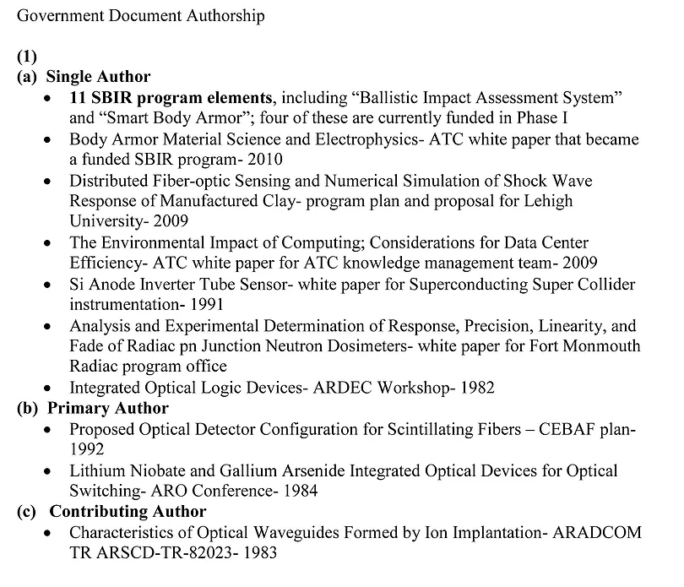
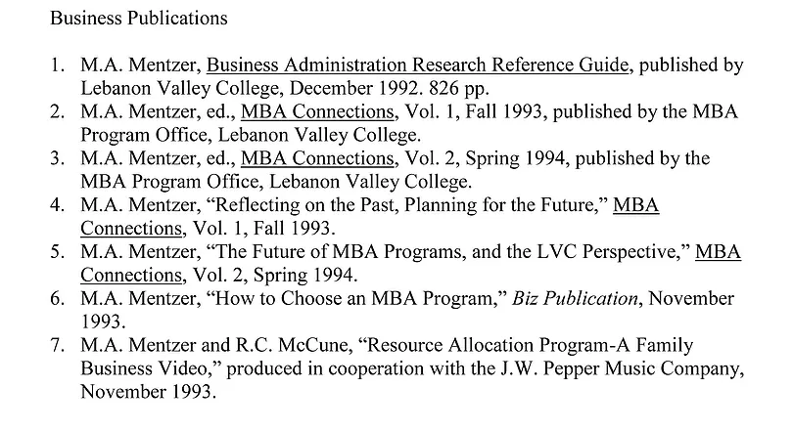

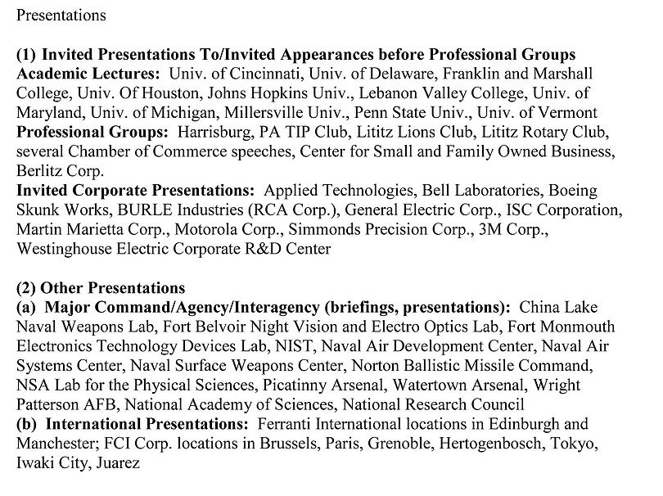
Interviews: Electronics Magazine, Lancaster Newspapers, Lucent Technology Council, PA Musicians Hall of Fame, Small Times MEMS Magazine, Eastern Shore Post, Eastern Shore Radio

Books and other works by Mark A. Mentzer

Invention Disclosures, Provisional, and Issued Patents
Note: A number of these disclosures were filed as provisional patents only; a group was packaged and sold as an IP portfolio to IBM, and several others were licensed to outside companies for subsequent filing groups. U.S., European, and International issues are noted.
1. Optical detection scheme for random access magnetic crosstie memory using Faraday rotation
2. Utilization of Franz-Keldysh absorption modulation for optical addressing of memory elements
3. Optical decoding for random access memory using electro-optic addressing
4. Practical electrooptic modulators and switches using ion-implanted waveguides
5. Ion implantation technique for integrated optic device-multiplexing geometries
6. Ion-implanted variable loss devices for integrated optical circuits and logic systems
7. Efficient grating fabrication for integrated optical circuits
8. Variable delay lines for optical communications systems
9. Schottky contact processing monitor
10. Acousto-optic deflection/scanning for random access memory addressing
11. Voight phase shift detection for magnetic crosstie memory random access readout
12. Photon-coupled isolators for RAM
13. Low-loss channel waveguides formed by ion implantation
14. Optical waveguide couplers formed by ion-implanted gratings
15. Improved detection scheme for XTIE memory using double complementary operation
16. Improved fabrication technique for surface and buried blazed transmission grating couplers
17. GaAs heterostructure implanted waveguides for low-loss propagation at 10.6 microns
18. Analog memory utilizing multistable logic in the magnetic crosstie random access memory
19. High efficiency GaAs depletion layer modulation directional coupler switch
20. Single pulse write and single pulse read crosstie memory
21. X-tie spatial light modulator
22. Ion-implanted switch/filter
23. Dielectric overlays for low-loss ion-implanted waveguide fabrication
24. Staggered S-Ram geometry for improved signal extraction in the crosstie random access memory
25. Cooltie crosstie memory
26. Magnetoresistive random access cross-tie memory architecture and signal processing system [U.S. Patent 4,722,073] [also international and European
filings]
27. Quad store crosstie memory with single pulse read and write
28. Crosstie memory system [U.S. Patent 4,841,480] [also international and European filings]
29. Magneto-optic two-dimensional spatial modulator
30. Signal-to-noise enhancement for crosstie memory Faraday rotation
31. Multiple structure cell
32. Methods and systems for determining the density and/or temperature of fluids [US Patent 7,573,565] [also international and European filings]
33. Liquid level sensor using fluorescence in an optical waveguide [International Patent WO 2004/008086]
34. Autocalibration circuit for color temperature and luminous flux
35. Actively aligned multi-fiber array
36. Systems and methods for determining the level and/or type of a fluid [U.S. Patent 7,710,567] [also international and European filings]
37. Methods and systems for detecting and/or determining the concentration of a fluid [U.S. Patent 7,768,646] [also international and European filings]*
38. Optical fiber connector with silicon locator
39. Angled optical connector [U.S. Patent 6,422,761] [also international and European filings]
40. Multi-fiber array connector system [U.S. Patent 6,447,171] [also international and European filings]
41. Systems and methods for generating optical energy using a light-emitting diode [U.S. Patent 7,671,539] [also international and European filings]*
42. Angled connector for miniMAC
43. Optical densitometer
44. Electro-optic fluid quantity measurement system [US Patent 6,831,290] [also international and European filings]
45. In the filing process by the U.S. Army: Blast, ballistic, and blunt trauma sensors exhibiting differential circular dichroism chirality shifts and color changes based on concurrent disruption of tissue and sensor phospholipid bilayers configured as liposomes

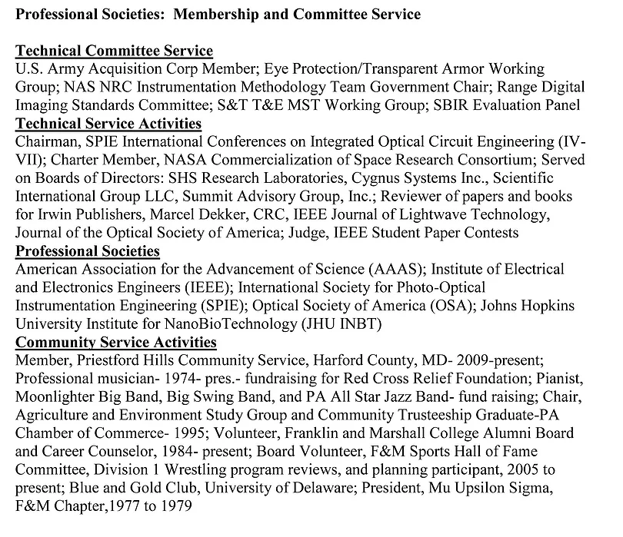

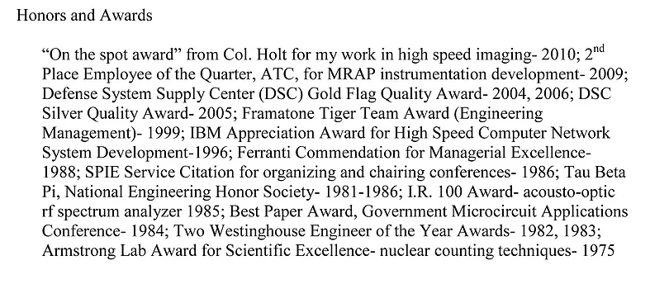

Detailed Teaching Experience

- Successfully taught several years in MD and VA public schools, and three years at private college prep schools

- Served as adjunct Associate and Full Professor at two major universities and a private liberal arts college

- Developed curricula for high schools and colleges and coordinated faculty

- Delivered multidisciplinary online private tutoring

- University of Maryland Global Campus 2016-present
Adelphi, MD online
Adjunct Associate Professor of Engineering and Computer Science
Course coordinator

- Eastern Shore Community College of Virginia 2017-2021
Melfa, VA
Adjunct Associate Professor of Mathematics
SAT/ACT Course Director

- WyzAnt Tutoring, Teaching, and Coaching 2012-present
Chicago, IL
Private Academic Tutor

- The Salisbury School 2018-2019
Salisbury, MD
Upper School Math and Physics Teacher

- Nandua High School 2017-2018
Onley, VA
Mathematics Teacher

- Broadwater Academy 2015-2017
Exmore, VA
Mathematics and Science Teacher
Director, Center for Integrated Math & Science

- Crisfield High School 2014-2015
Crisfield, MD
Mathematics Teacher

- Lebanon Valley College 1991-1994
Annville, PA
Dean of MBA Program
Associate Professor of Business Administration and Physics

- Penn State University
Middletown and State College, PA 1984-1990
Adjunct Assistant Professor of Electrical Engineering

- Supervised theses and dissertations at four Universities 1981-1989

- University of Delaware 1979-1980
Newark, DE
Research Fellow
Taught senior-level electromagnetics and solid-state physics labs

High School Courses Taught
Algebra 1, Algebra 2, College Algebra, Honors Algebra 2, Geometry, College Prep Geometry, Honors Geometry, Algebra, Functions, Data and Analysis, Trigonometry, Precalculus, Honors Precalculus, AP Calculus AB, AP Calculus BC, Mathematics for Engineering and the Life Sciences, Advanced Problem Solving, Technical Writing, Biochemistry and Molecular Genetics, Marine Technology, Engineering and Robotics, SAT/ACT Prep

College and University Courses and Seminars Taught
Materials and Metallurgy, Advanced Fields and Waves, Electronic Design, Fiber Optic Communications, Optical Engineering, Fundamentals of Physics, Integrated Optics, Solid State Devices, Semiconductor Devices, Semiconductor Physics, Electro-Optics, Microwave Devices, EO Sensor Systems, Smart Sensors, Engineering Management, Audio Electronics, Quantitative Analysis, Business Policy Capstone, Entrepreneurship, Physics of Music, Information Systems Analysis, Thinking Logically, College Precalculus, Statistics, College Calculus

UMGC Courses Taught
ITEC 630 Information Systems Analysis, Modeling, and Design
SYSE 625 Model-Based Systems Engineering
SYSE 650 Design Considerations

This I Believe- Why I Want to Teach

Mark A. Mentzer PhD

Whenever I see a student’s eyes open to the possibilities in understanding engineering, math, and science, I am reminded of why I teach. As an Adjunct Associate Professor of Engineering and Computer Science at UMGC, my students show excitement and amazement as we discover the powers of the engineering disciplines. My satisfaction derives from the students’ positive responses as I help them develop and perform to their full potential. In some high-need students, I find the most significant potential for improvement and success, and we have been able to overcome the most daunting obstacles to personal progress.
​
I anticipate many further challenges. These include the development of flexible classroom management skills and techniques to address the needs of an entire class while embracing unique individual student requirements. I find such a diversity of learning paradigms, study skills, and understanding of problem-solving methodologies, and I eagerly anticipate my assimilation of new teaching methods and successful teaching experiences.
​
It seems many classroom scenarios represent an urgent need for improved communication- especially with struggling students. This should be coupled with transmission to distracted students and others regarding the end-of-term assessments and the type and nature of those exercises. Having tutored for many achievement tests, I believe student confidence and performance can be elevated through properly focused preparation for those exams. This would be coupled with the required curricula in an integrated fashion so that mathematic and scientific analytical skills provide a foundation for more comprehensive learning processes.
​
I implement improved value propositions for the most troubled students and reward and acknowledge reasonable efforts. Rather than trying to "make" the students perform in a particular manner, they must be shown the results of their positive actions. Individual tutoring and direct communication improve overall performance as elevated trust and respect ensues from the ongoing process of teaching the value of the learning process.
​
I chose many of these strategies based on positive experiences in my tutoring and teaching. My experience as a private tutor and academic counselor to a wide range of student abilities and educational levels also motivated my decision to continue teaching at the graduate level. I love the process of continuous improvement and evolution of my teaching skills, focusing on students awakening to their possibilities.
​
I genuinely believe that all students have the potential to achieve their very best, and I would suggest this equates to "high academic achievement." I recently tutored a troubled individual for his GED exams. He felt strongly that, while his wife and family were rooting for him, and everyone thought he could accomplish his diploma, he could not understand the subject matter to the level needed to pass his exams. He spent many years, up to the age of 42, with that self-doubt but was finally ready to face the challenge of the GED directly.
​
I began by discussing the academic struggles that led to the student dropping out in the tenth grade. Then I showed him a few questions from each area of the GED to give him a feel for our challenge. And I took on the challenge for myself and assured him that together we would learn the material and put in the time and effort- no matter what that represented- so he could pass the GED. We worked several nights weekly for three months, never stopping until we worked at least three hours. I gave him additional assignments, which he completed in time for our sessions. We worked on hundreds of problems together; then, I slowly backed away as he could complete answers independently. I went home at night, barely able to sleep, as the excitement grew with this student's progress.
​
Finally, it was time for his first test. It was graded at the exam site, and he received his results immediately. When I showed up for our next session, he and his wife greeted me at their door, giving me a big hug. With tears in his eyes, he informed me he not only passed the first of five exams, but his score was rather sensational! That student passed all five exams; I recently attended a party celebrating his diploma with his friends and family!
​
While I did not admit this to the student, I felt his passing the GED was a long shot, based on our starting point. But I now know that if I can gain the attention of the students, engage them in a concerted value proposition, personally accept the very same challenge faced by the student, instill trust that I am fully committed to their (and our) success- then I know that the likelihood of high academic achievement is indeed very high. I want to take the long shots.
​
I truly value education and the personal satisfaction I feel seeing student progress. That GED student saved all our notes and problems, my lecture materials, and handwritten diagrams and placed them into a scrapbook, along with his passing test scores and diploma. What a great feeling that represented everyone involved! I am committed to that same challenge in whichever classroom I may serve.
​
Good teachers must assume a very high responsibility for what transpires with the student’s successful performance. Indeed, students are not innately equipped with the knowledge of how to optimize their academic success; this should be part of the education delivered by the teacher. When students are shown how to succeed, I find that they begin experimenting with their own capabilities. I feel great satisfaction, seeing the look of recognition as they begin to extend themselves- solving a problem, suggesting a possible solution, and then realizing they just did something they hadn't learned they were capable of. I take responsibility for the learning process and strive to apply it in the best manner possible for each classroom and each individual involved. I anticipate students taking increased responsibility for their academic success, as they are equipped with the tools allowing them to progress on their initiatives. I believe this is how I will best spend the remainder of my career to provide the most benefit to the learning communities I serve.
​

